Butler County Board of Education

Announces its policy for Free and Reduced Price Meals for students under the

NATIONAL SCHOOL LUNCH AND BREAKFAST PROGRAMS.

Any interested person may review a copy of the policy by contacting Hazel Short, 203 N Tyler Street, Morgantown, and 270-526-5624.

Household size and income criteria will be used to determine eligibility. Children from families whose income is at or below the levels shown may be eligible for Free or Reduced Price Meals. Application forms are being sent to all homes with a letter to parents or guardians. To apply for Free or Reduced Price Meals, households must complete the application and return it to the school. Only one application is required for all children in the household. Additional copies are available at each school or the Butler County Board of Education Office at 203 N Tyler Street, Morgantown.

An application cannot be approved unless it contains complete eligibility information:
- Total household income listed by gross amount received, type of income (e.g., wages, child support, etc.) and how often the income is received by each household member;
- Names of all household members;
- Signature of an adult household member certifying the information provided is correct; and
- The last four digits of the social security number of the adult signing the application or the word “NONE” for this household member if he or she does not have a social security number.

The information provided on the application will be used for the purpose of determining eligibility and may be verified at any time during the school year. Applications may be submitted at any time during the year.

For the purpose of determining household size, deployed military members are considered a part of the household. Families should include the names of the deployed service members on their application. Report only that portion of the deployed service member’s income made available to them or on their behalf to the family. Additionally, a housing allowance that is part of the Military Housing Privatization Initiative is not to be included as income.

Once approved, meal benefits are good for the current school year and up to 30 operating days into the next school year. When the carry-over period ends, unless the household is notified that their children are directly certified or the household submits an application that is approved, the children must pay full price for school meals. Households will not be sent a reminder or notice of expired eligibility. If a household member becomes unemployed or if the household size changes, the school should be contacted. Such changes may make the student eligible for reduced price or free meals.

All children in households that receive SNAP or KTAP are eligible for free meals. When known to Butler County Board of Education, households will be notified of their children’s eligibility for free meals if they are members of a household that receives SNAP or KTAP benefits. No application is necessary for these households. All children in these households are eligible for free meal benefits. If any child(ren) was not listed on the eligibility notice, the household should contact Hazel Short to have free meal benefits extended to that child(ren). If the household is not sure if their children have been directly, certified, they should contact the school.

For households not notified of children’s eligibility for free meals in which any household member receives SNAP or KTAP benefits, an application may be completed to receive free meals. Households are required to list on the application only the child’s name, SNAP / KTAP case number, and signature of adult household member. Categorical eligibility for free meals is extended to all children in a household when the application lists an Assistance Program’s case number for any household member.

Foster children are categorically eligible for free meals and will receive benefits based on information submitted on the household application or information received from an appropriate agency. Foster children may be included as a member of the foster family if the foster family chooses to also apply for benefits for other children. Including children in foster care as household members may help other children in the household qualify for meal benefits. If the foster family is not eligible for free or reduced price meal benefits, it does not prevent a foster child from receiving free meal benefits.

Children in households participating in WIC or who reside in households where parents or guardians become unemployed may be eligible for free or reduced price meals. Please fill out an application.

When known, Butler County Board of Education will notify households of any child’s eligibility for free meals if the individual child is Other Source Categorically Eligible because the child is categorized as homeless, migrant or runaway as defined by law or enrolled in an eligible Head Start, Even Start or pre-kindergarten class as defined in by law.

Household with children who are considered migrants, homeless, or runaway should contact the district liaison, Hazel Short at 270-526-5624 for assistance in receiving benefits. A household application may also be submitted with an indication of their Other Source Categorically Eligibility marked in the relevant box on the application.

Under the provisions of the Free and Reduced Price meal policy, Hazel Short, 270-526-5624 will review applications and determine eligibility. If a parent or guardian is dissatisfied with the ruling of the official, he or she may wish to discuss the decision with the determining official on an informal basis. If the parent wishes to make a formal appeal, he or she may make a request either orally or in writing to Scott Howard, Superintendent at 270-526-5624

Any questions about the application process may be directed to Hazel Short, 270-526-5624

In accordance with the Sponsor’s disclosure agreement, the information on the Free and Reduced Price Meal application may be used by the school system in determining eligibility for other educational programs. Households notified of their children’s eligibility must contact Butler County Board of Education if it chooses to decline the free meal benefits.

INCOME ELIGIBILITY GUIDELINESFOR FREE AND REDUCED PRICE MEALS
Effective from July 1, 2014, to June 30, 2015
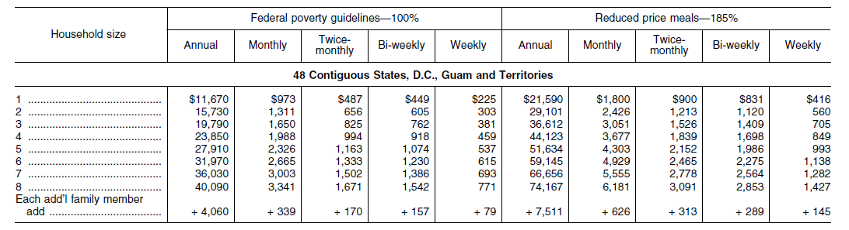
To determine annual income:
- If you receive the income every week, multiply the total gross income by 52.
- If you receive the income every two weeks, multiply the total gross income by 26.
- If you receive the income twice a month, multiply the total gross income by 24.
- If you receive the income monthly, multiply the total gross income by 12.

Remember: The total income before taxes, social security, health benefits, union dues, or other deductions must be reported.

“The U.S. Department of Agriculture (USDA) prohibits discrimination against its customers, employees, and applicants for employment on the bases of race, color, national origin, age, disability, sex, gender identity, religion, reprisal, and where applicable, political beliefs, marital status, familial or parental status, sexual orientation, or if all or part of an individual's income is derived from any public assistance program, or protected genetic information in employment or in any program or activity conducted or funded by the Department. (Not all prohibited bases will apply to all programs and/or employment activities.)

If you wish to file a Civil Rights program complaint of discrimination, complete the USDA Program Discrimination Complaint Form, found online at http://www.ascr.usda.gov/complaint_filing_cust.html, or at any USDA office, or call (866) 632-9992 to request the form. You may also write a letter containing all of the information requested in the form. Send your completed complaint form or letter to us by mail at U.S. Department of Agriculture, Director, Office of Adjudication, 1400 Independence Avenue, S.W., Washington, D.C. 20250-9410, by fax (202) 690-7442 or email at program.intake@usda.gov.

Individuals who are deaf, hard of hearing or have speech disabilities may contact USDA through the Federal Relay Service at (800) 877-8339; or (800) 845-6136 (in Spanish).

USDA is an equal opportunity provider and employer.”

